Architecture Document
Project Title: Shipment Pricing Prediction
Domain: Supply Chain Analytics
Difficulty Level: Intermediate
Cloud Provider: AWS

Table of Contents
- Introduction
- High-Level Architecture
- Component-Level Architecture (Flowcharts, Explanations, and Sequence Diagrams)
  - 3.1 Data Ingestion
  - 3.2 Data Validation
  - 3.3 Data Transformation
  - 3.4 Model Trainer
  - 3.5 Model Evaluation
  - 3.6 Model Pusher
  - 3.7 Cost Model
  - 3.8 S3 to Local
- Pipeline-Level Architecture (Flowcharts, Explanations, and Sequence Diagrams)
  - 4.1 Training Pipeline
  - 4.2 Prediction Pipeline
- Application Layer (FastAPI)
- Deployment & Infrastructure
- Error Handling & Logging
- Security & Compliance
- Conclusion

1. Introduction
The Shipment Price Prediction system is designed to automate data ingestion, validation, transformation, model training, evaluation, and deployment for predicting shipment prices. This document provides a detailed architectural view of the system, including flowcharts, sequence diagrams, and process explanations.

2. High-Level System Architecture
System Execution Flow:

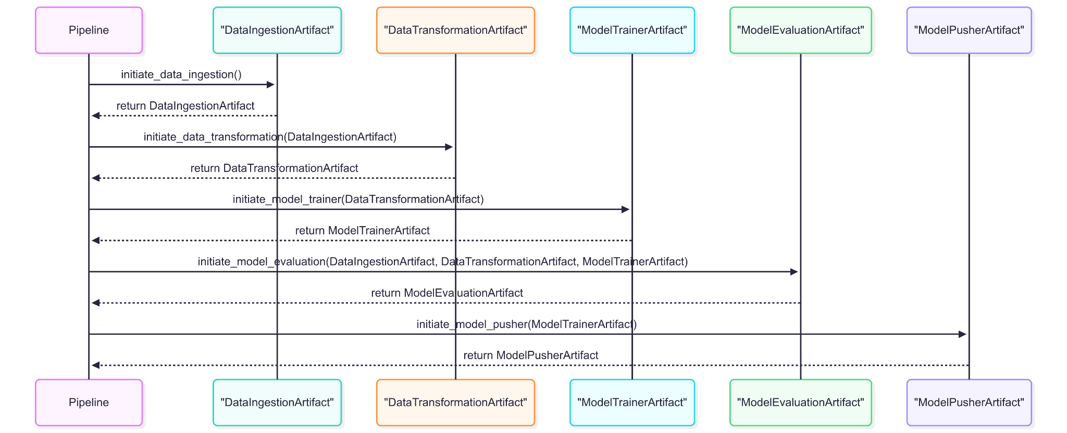

3. Component-Level Architecture
Each component is explained with its flowchart, sequence diagram, and flow explanation.

3.1 Data Ingestion
Description: Responsible for fetching raw shipment data from MongoDB, cleaning it, handling duplicates/missing values, and splitting into train/test sets.
Flowchart Image here:
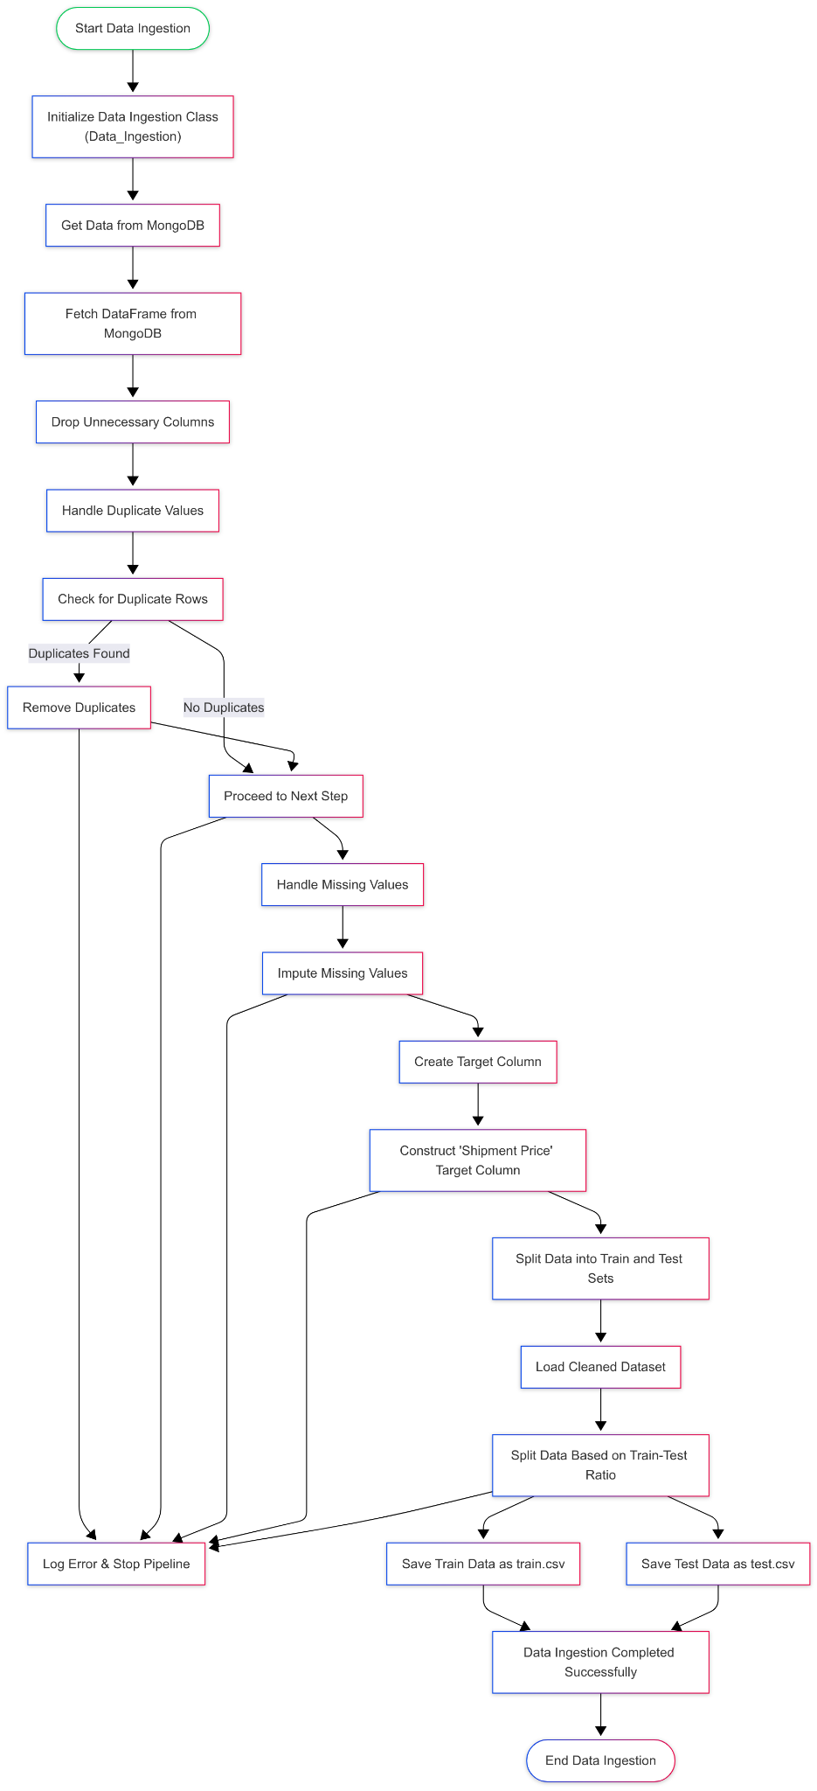

Explanation of Flowchart Components Data_Ingestion:
● Start Data Ingestion: The entry point of the data ingestion process.
● Initialize Data Ingestion Class: Instantiation of the Data_Ingestion class.
● Get Data from MongoDB: Fetching data from the MongoDB database.
● Fetch DataFrame from MongoDB: Retrieving the data as a DataFrame.
● Drop Unnecessary Columns: Removing columns that are not needed for analysis.
● Handle Duplicate Values: Checking and removing duplicate rows if found.
● Check for Duplicate Rows: Identifying duplicates in the dataset.
● Remove Duplicates: Removing duplicate entries from the dataset.
● Proceed to Next Step: Continuing to the next step if no duplicates are found.
● Handle Missing Values: Identifying and handling missing values in the dataset.
● Impute Missing Values: Applying imputation strategies to fill in missing values.
● Create Target Column: Creating the target variable for the dataset.
● Construct 'Shipment Price' Target Column: Summing specific columns to create the target variable.
● Split Data into Train and Test Sets: Splitting the cleaned dataset into training and testing datasets.
● Load Cleaned Dataset: Loading the cleaned dataset for splitting.
● Split Data Based on Train-Test Ratio: Performing the split based on the specified ratio.
● Save Train Data as train.csv: Saving the training dataset to a CSV file.
● Save Test Data as test.csv: Saving the testing dataset to a CSV file.
● Data Ingestion Completed Successfully: Indicating the successful completion of the data ingestion process.
● End Data Ingestion: The exit point of the data ingestion process.
● Log Error & Stop Pipeline: Handling any errors that occur during the ingestion process.

Sequence Diagram Image here:

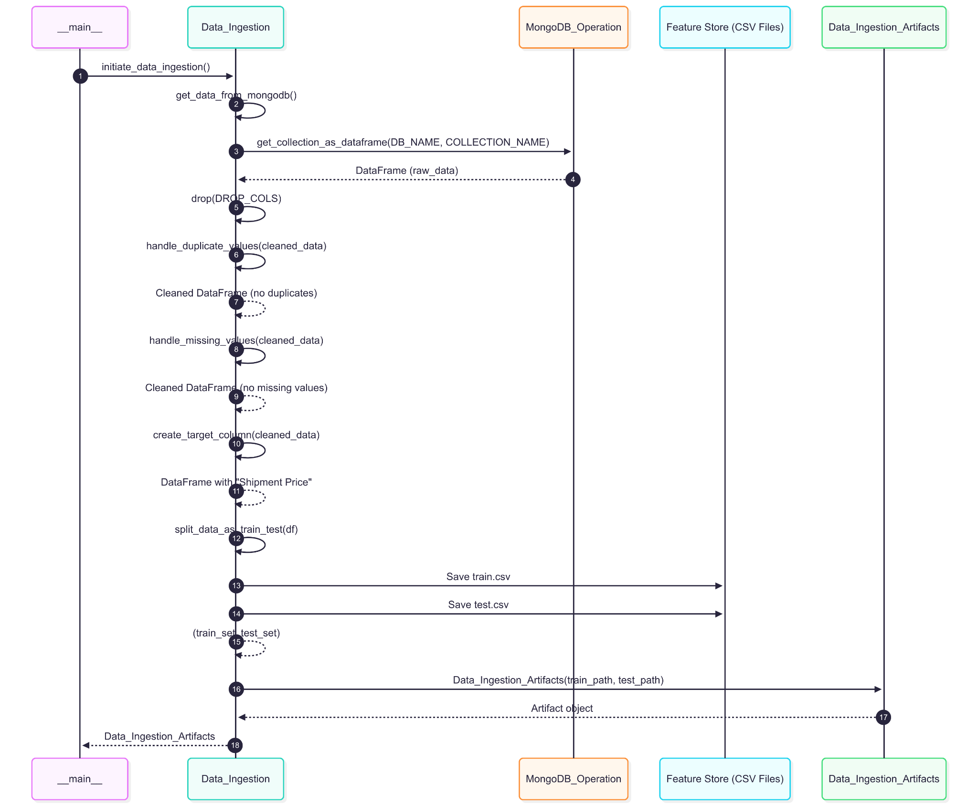

3.2 Data Validation
Description: Ensures the ingested data matches schema, checks for drift, and validates categorical/numerical columns.
Flowchart Image here:
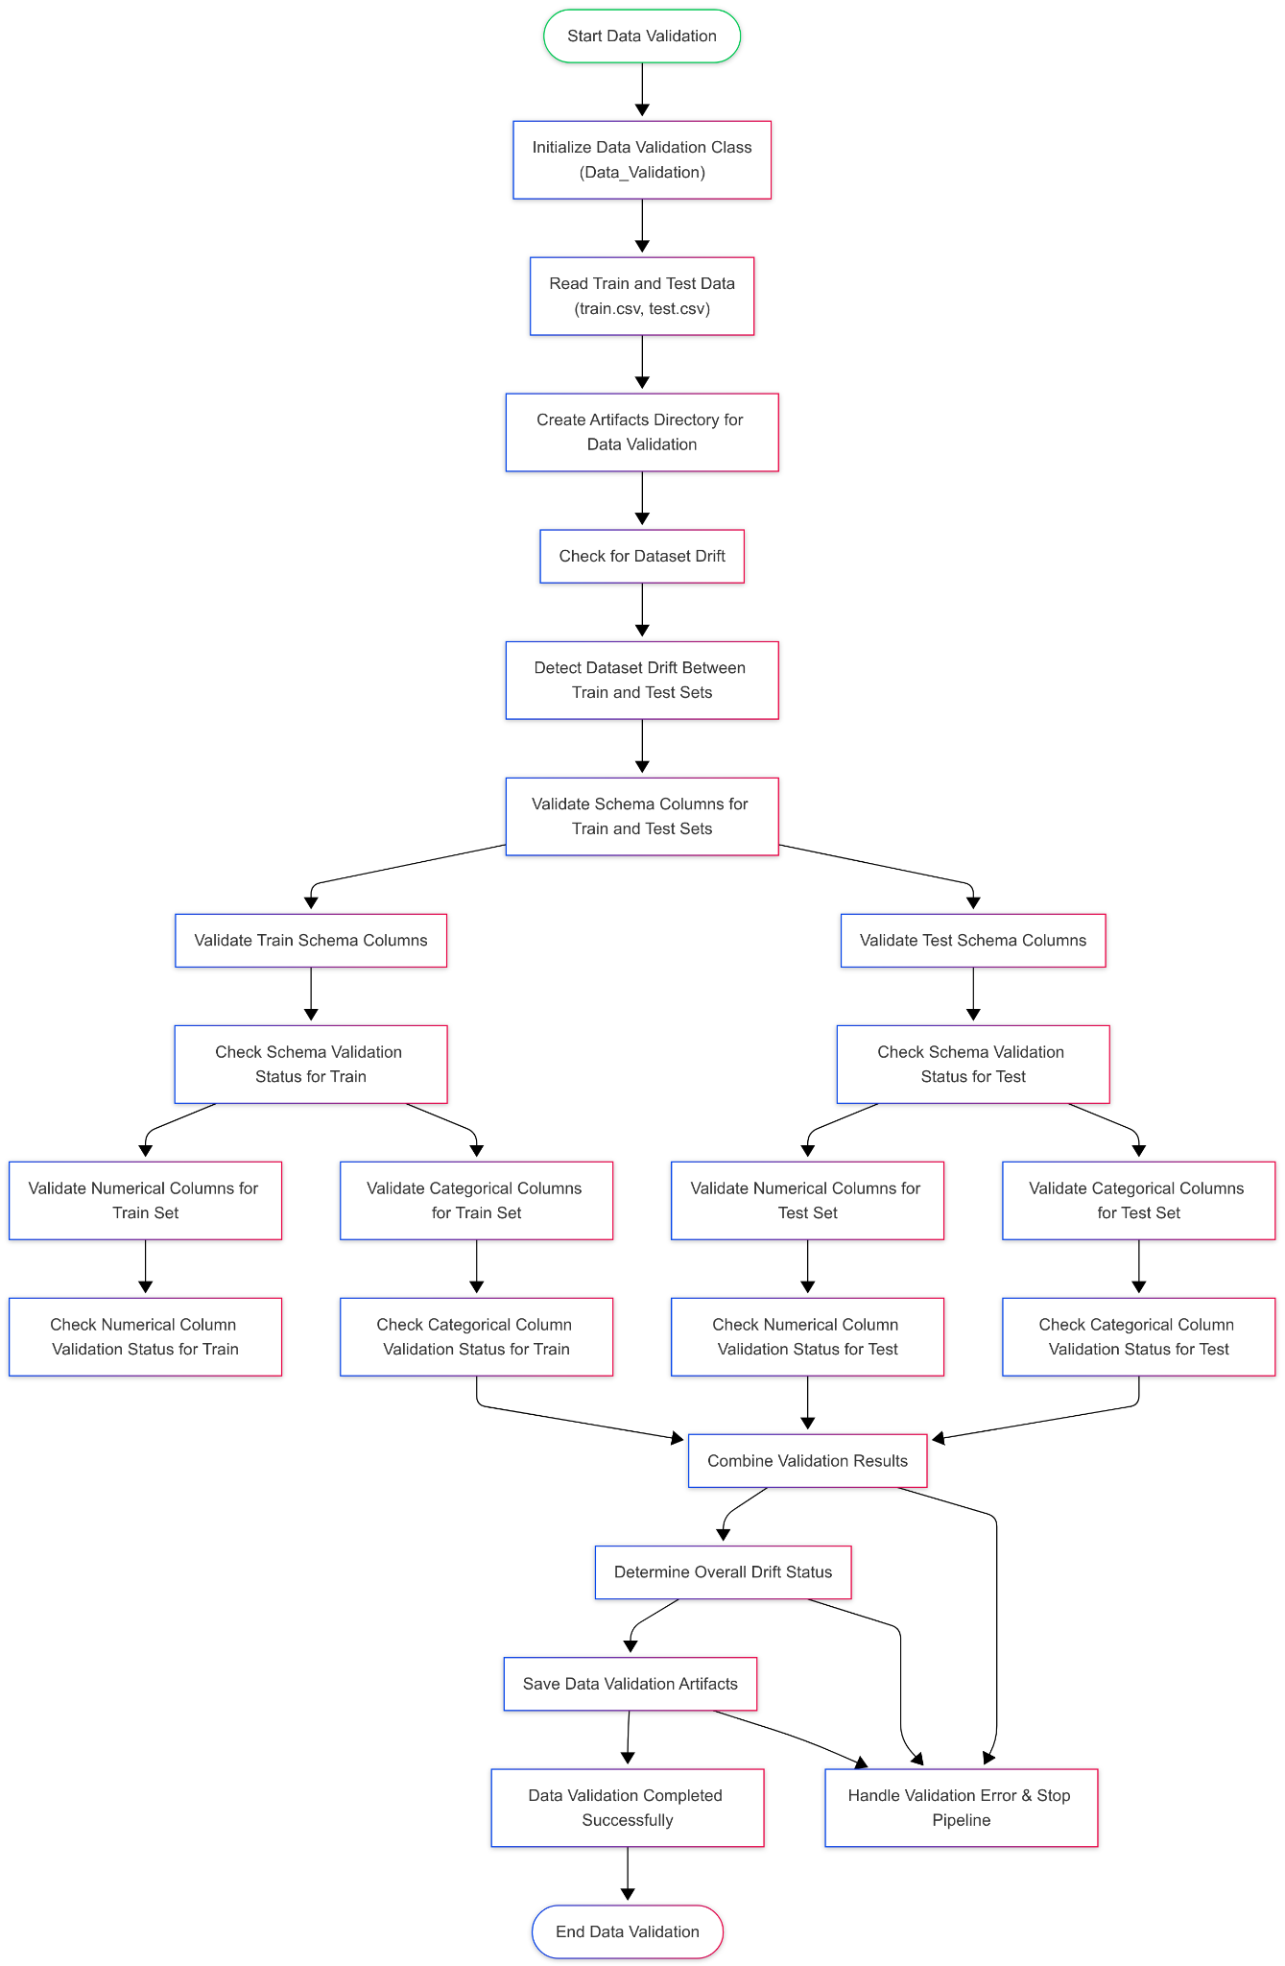

Explanation of Flowchart Components Data_Validation:
● Start Data Validation: The entry point of the data validation process.
● Initialize Data Validation Class: Instantiation of the Data_Validation class.
● Read Train and Test Data: Loading the datasets from specified file paths.
● Create Artifacts Directory for Data Validation: Creating a directory to save validation artifacts.
● Check for Dataset Drift: Detecting drift between the training and testing datasets.
● Detect Dataset Drift Between Train and Test Sets: Analyzing drift using the detect_dataset_drift method.
● Validate Schema Columns for Train and Test Sets: Validating the schema of both datasets.
● Validate Train Schema Columns: Checking if the schema columns in the training dataset match the expected schema.
● Validate Test Schema Columns: Checking if the schema columns in the testing dataset match the expected schema.
● Check Schema Validation Status for Train: Assessing the validation status of the training dataset.
● Check Schema Validation Status for Test: Assessing the validation status of the testing dataset.
● Validate Numerical Columns for Train Set: Checking for the existence of numerical columns in the training dataset.
● Check Numerical Column Validation Status for Train: Assessing the validation status of numerical columns in the training dataset.
● Validate Numerical Columns for Test Set: Checking for the existence of numerical columns in the testing dataset.
● Check Numerical Column Validation Status for Test: Assessing the validation status of numerical columns in the testing dataset.
● Validate Categorical Columns for Train Set: Checking for the existence of categorical columns in the training dataset.
● Check Categorical Column Validation Status for Train: Assessing the validation status of categorical columns in the training dataset.
● Validate Categorical Columns for Test Set: Checking for the existence of categorical columns in the testing dataset.
● Check Categorical Column Validation Status for Test: Assessing the validation status of categorical columns in the testing dataset.
● Combine Validation Results: Aggregating the results of all validation checks.
● Determine Overall Drift Status: Assessing whether the overall validation was successful or not.
● Save Data Validation Artifacts: Saving the results and reports of the validation process.
● Data Validation Completed Successfully: Indicating the successful completion of the data validation process.
● End Data Validation: The exit point of the data validation process.
● Handle Validation Error & Stop Pipeline: Handling any errors that occur during the validation process.
Sequence Diagram Image here:
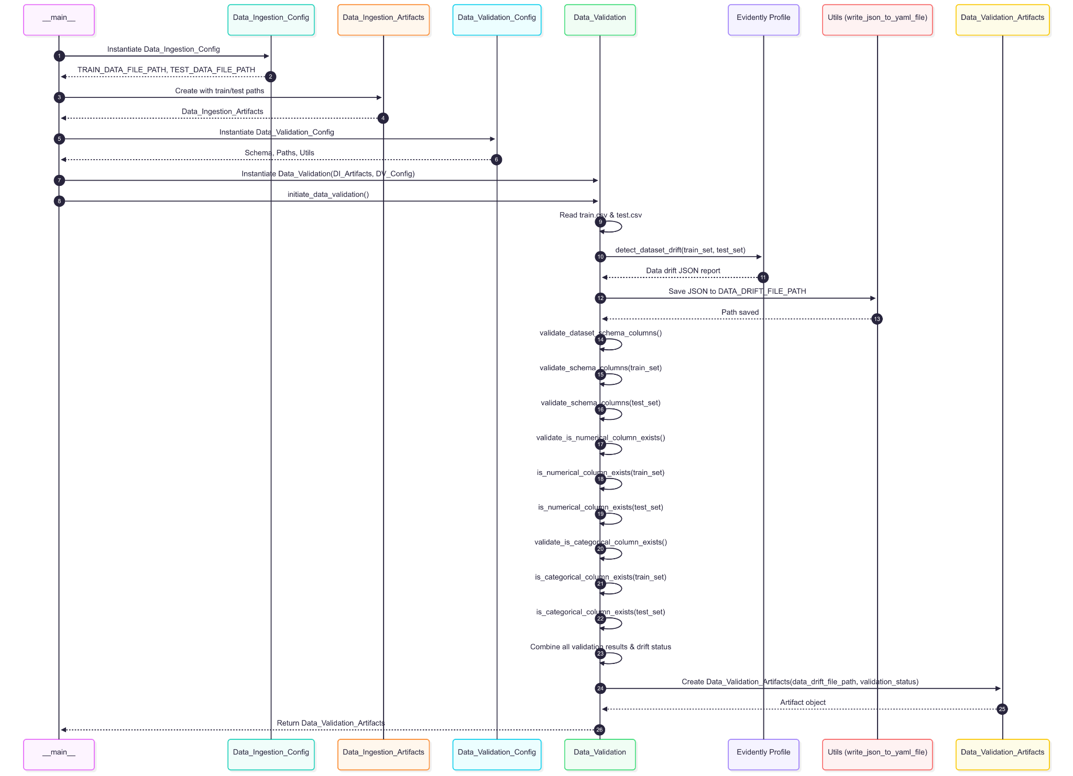

3.3 Data Transformation
Description: Prepares datasets for ML training, including imputation, encoding, outlier handling, and preprocessing pipelines.
Flowchart Image here:
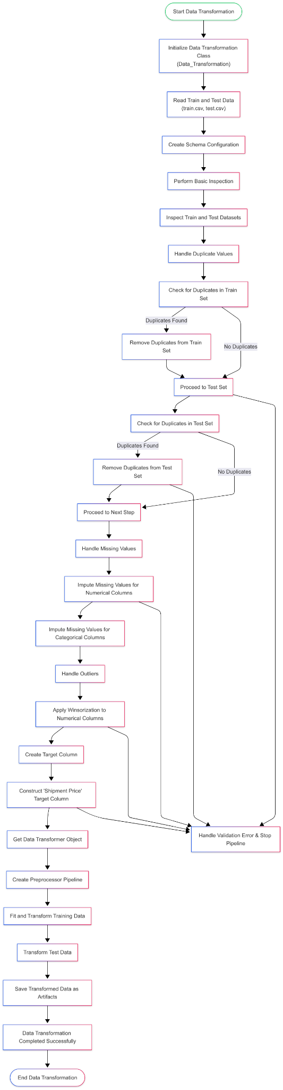

Explanation of Flowchart Components Data_Transformation :
● Start Data Transformation: The entry point of the data transformation process.
● Initialize Data Transformation Class: Instantiation of the Data_Transformation class.
● Read Train and Test Data: Loading the datasets from specified file paths.
● Create Schema Configuration: Reading the schema configuration for data transformation.
● Perform Basic Inspection: Conducting an initial inspection of the datasets.
● Inspect Train and Test Datasets: Analyzing the structure and quality of both datasets.
● Handle Duplicate Values: Checking and removing duplicate rows from the datasets.
● Check for Duplicates in Train Set: Identifying duplicates in the training dataset.
● Remove Duplicates from Train Set: Removing duplicate entries from the training dataset.
● Proceed to Test Set: Continuing to check for duplicates in the testing dataset.
● Check for Duplicates in Test Set: Identifying duplicates in the testing dataset.
● Remove Duplicates from Test Set: Removing duplicate entries from the testing dataset.
● Proceed to Next Step: Continuing to the next step if no duplicates are found.
● Handle Missing Values: Identifying and handling missing values in the datasets.
● Impute Missing Values for Numerical Columns: Applying imputation strategies for numerical columns.
● Impute Missing Values for Categorical Columns: Applying imputation strategies for categorical columns.
● Handle Outliers: Managing outliers in the datasets.
● Apply Winsorization to Numerical Columns: Capping extreme values in numerical columns.
● Create Target Column: Creating the target variable for the dataset.
● Construct 'Shipment Price' Target Column: Summing specific columns to create the target variable.
● Get Data Transformer Object: Retrieving the preprocessor object for data transformation.
● Create Preprocessor Pipeline: Setting up the transformation pipeline.
● Fit and Transform Training Data: Applying the preprocessor to the training dataset.
● Transform Test Data: Applying the preprocessor to the testing dataset.
● Save Transformed Data as Artifacts: Saving the processed datasets and preprocessor object for future use.
● Data Transformation Completed Successfully: Indicating the successful completion of the data transformation process.
● End Data Transformation: The exit point of the data transformation process.
● Handle Validation Error & Stop Pipeline: Handling any errors that occur during the transformation process.
Sequence Diagram Image here:
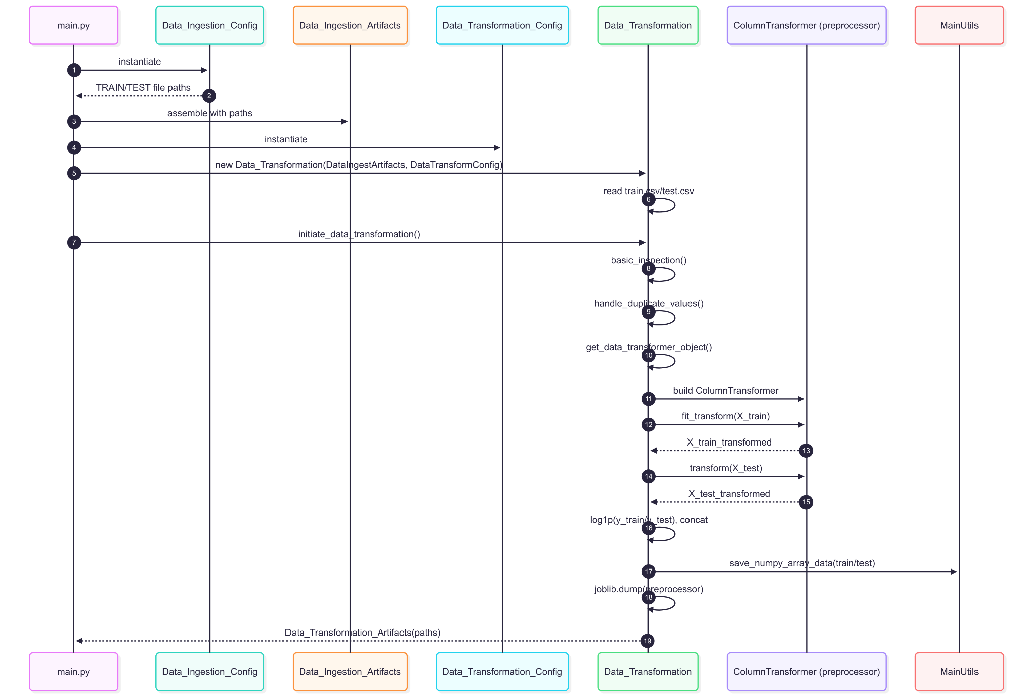

3.4 Model Trainer
Description: Trains multiple ML models, selects the best model, and saves it.
Flowchart Image here:
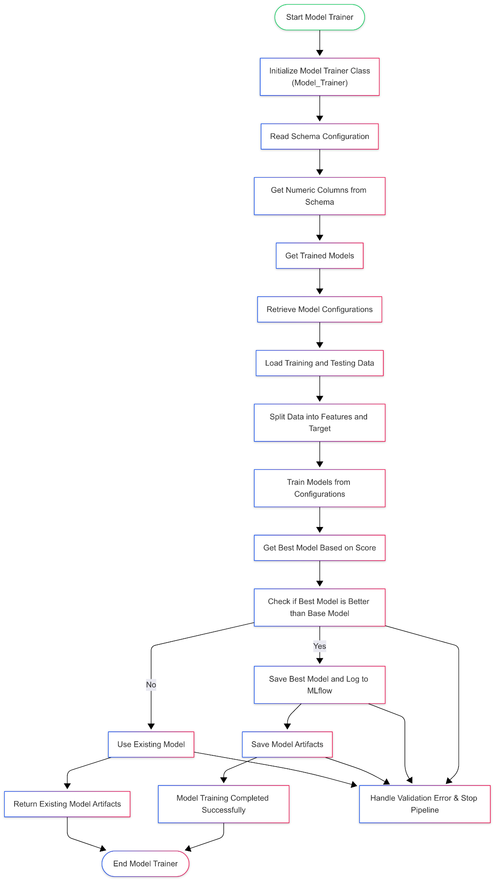

Explanation of Flowchart Components Model_Trainer:
● Start Model Trainer: The entry point of the model training process.
● Initialize Model Trainer Class: Instantiation of the Model_Trainer class.
● Read Schema Configuration: Loading the schema configuration for model training.
● Get Numeric Columns from Schema: Retrieving the numeric feature columns from the schema.
● Get Trained Models: Initiating the process to retrieve and train models.
● Retrieve Model Configurations: Loading model configurations from the specified file.
● Load Training and Testing Data: Reading the training and testing datasets.
● Split Data into Features and Target: Separating the features and target variable from the datasets.
● Train Models from Configurations: Training the models based on the configurations provided.
● Get Best Model Based on Score: Identifying the best model based on performance metrics.
● Check if Best Model is Better than Base Model: Comparing the best model's score with the base model's score.
● Save Best Model and Log to MLflow: Saving the best model and logging relevant information to MLflow.
● Save Model Artifacts: Storing the model artifacts for future use.
● Model Training Completed Successfully: Indicating the successful completion of the model training process.
● Use Existing Model: If no better model is found, using the existing model.
● Return Existing Model Artifacts: Returning the artifacts of the existing model.
● End Model Trainer: The exit point of the model training process.
● Handle Validation Error & Stop Pipeline: Handling any errors that occur during the training process.
Sequence Diagram Image here:
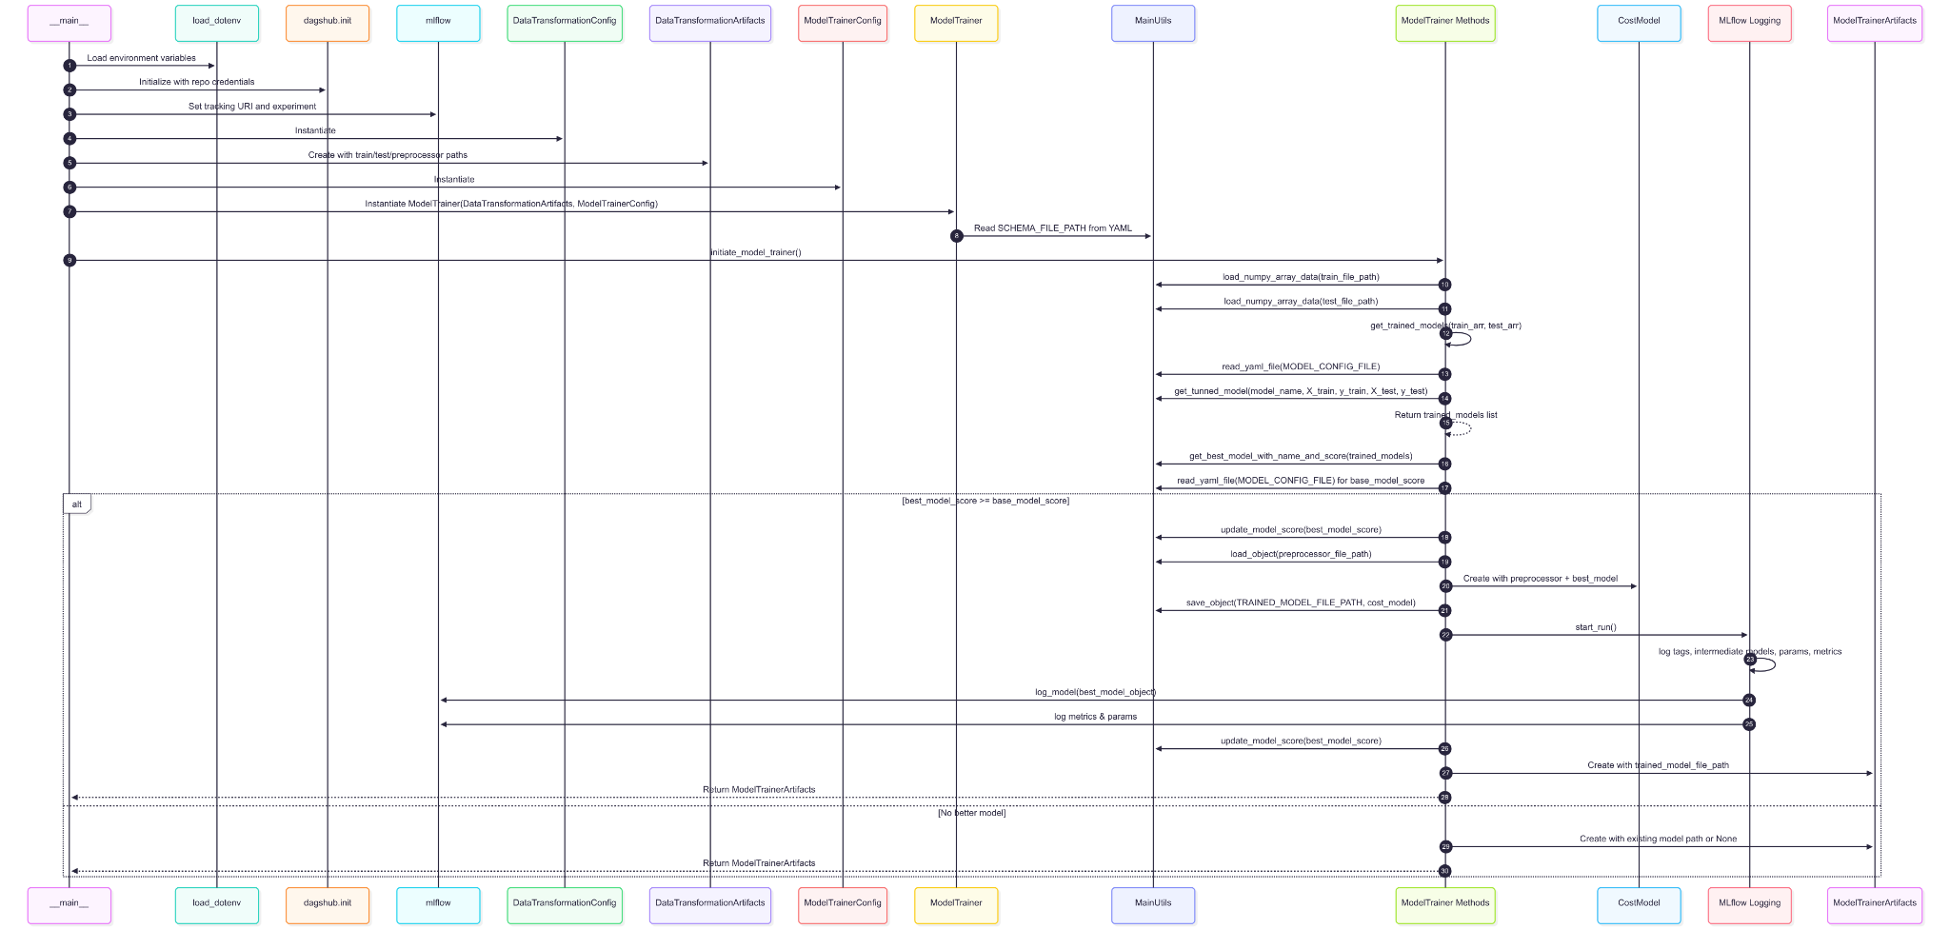

3.5 Model Evaluation
Description: Compares the new trained model with the best S3-stored model using R² score and selects the better one.
Flowchart Image here:
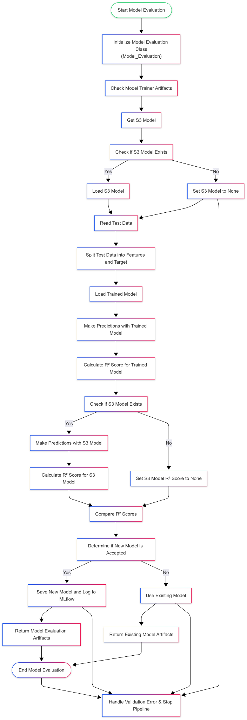

Explanation of Flowchart Components Model_Trainer:
● Start Model Trainer: The entry point of the model training process.
● Initialize Model Trainer Class: Instantiation of the Model_Trainer class.
● Read Schema Configuration: Loading the schema configuration for model training.
● Get Numeric Columns from Schema: Retrieving the numeric feature columns from the schema.
● Get Trained Models: Initiating the process to retrieve and train models.
● Retrieve Model Configurations: Loading model configurations from the specified file.
● Load Training and Testing Data: Reading the training and testing datasets.
● Split Data into Features and Target: Separating the features and target variable from the datasets.
● Train Models from Configurations: Training the models based on the configurations provided.
● Get Best Model Based on Score: Identifying the best model based on performance metrics.
● Check if Best Model is Better than Base Model: Comparing the best model's score with the base model's score.
● Save Best Model and Log to MLflow: Saving the best model and logging relevant information to MLflow.
● Save Model Artifacts: Storing the model artifacts for future use.
● Model Training Completed Successfully: Indicating the successful completion of the model training process.
● Use Existing Model: If no better model is found, using the existing model.
● Return Existing Model Artifacts: Returning the artifacts of the existing model.
● End Model Trainer: The exit point of the model training process.
● Handle Validation Error & Stop Pipeline: Handling any errors that occur during the training process.
Sequence Diagram Image here:
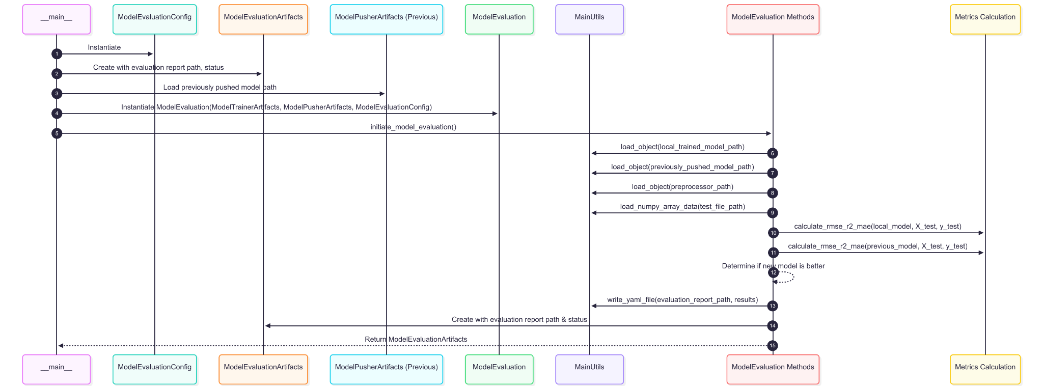

3.6 Model Pusher
Description: Pushes the accepted best model to S3 for persistence and deployment.
Flowchart Image here:
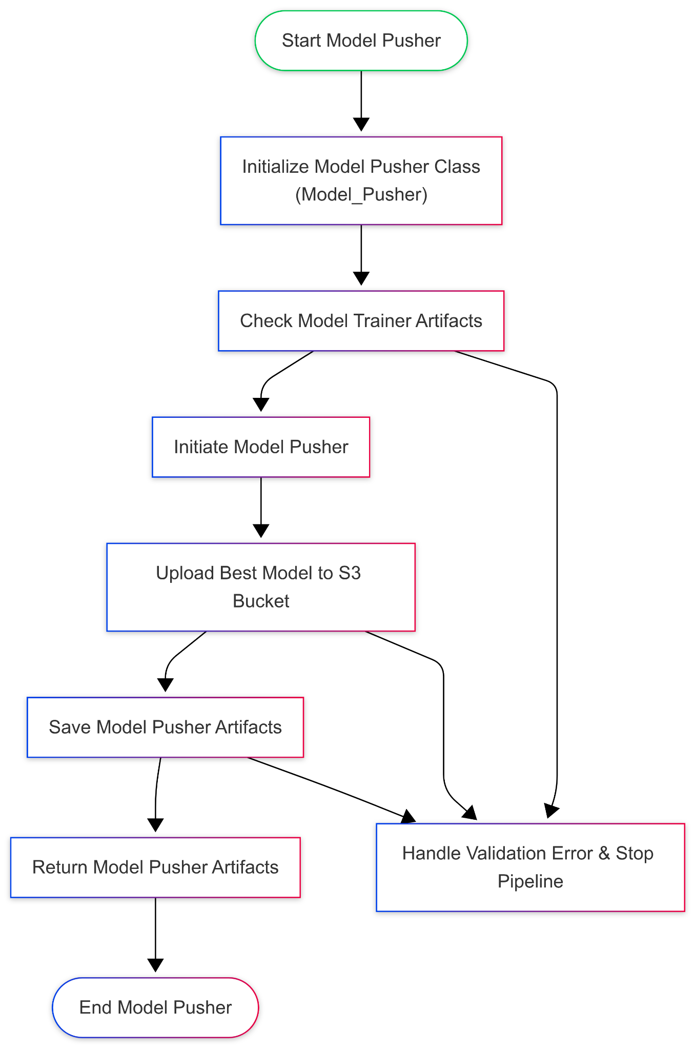

Explanation of Flowchart Components Model_Pusher :
● Start Model Pusher: The entry point of the model pusher process.
● Initialize Model Pusher Class: Instantiation of the Model_Pusher class.
● Check Model Trainer Artifacts: Verifying that the model trainer artifacts are properly initialized.
● Initiate Model Pusher: Starting the process to push the model to S3.
● Upload Best Model to S3 Bucket: Uploading the trained model to the specified S3 bucket.
● Save Model Pusher Artifacts: Saving the artifacts related to the model pusher.
● Return Model Pusher Artifacts: Returning the artifacts of the model pusher.
● End Model Pusher: The exit point of the model pusher process.
● Handle Validation Error & Stop Pipeline: Handling any errors that occur during the pusher process.
Sequence Diagram Image here:
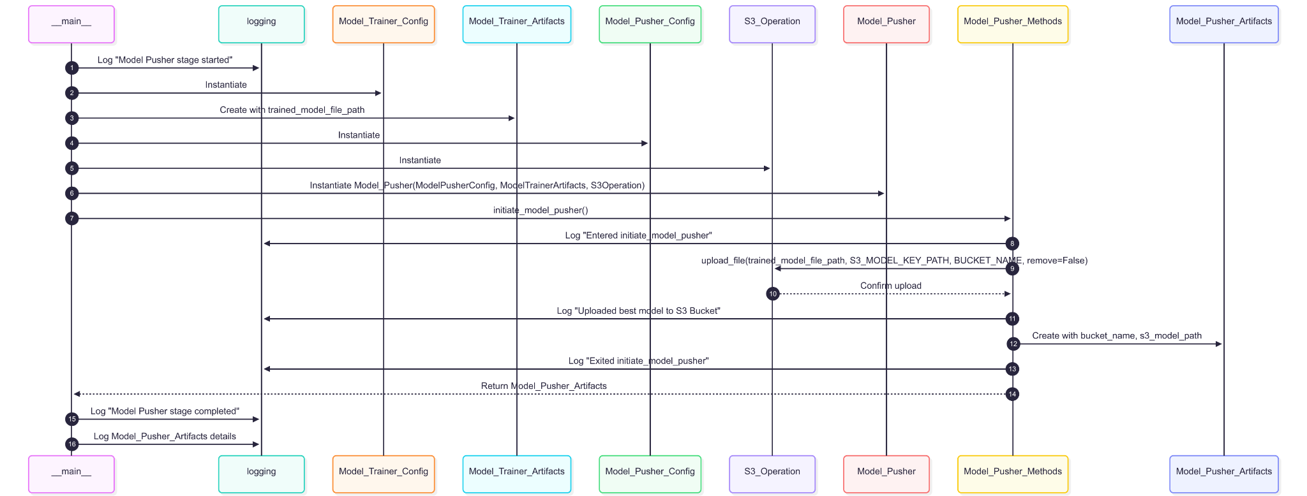

3.7 Cost Model
Description: Uses the trained model to predict shipment price for incoming data.
Flowchart Image here:
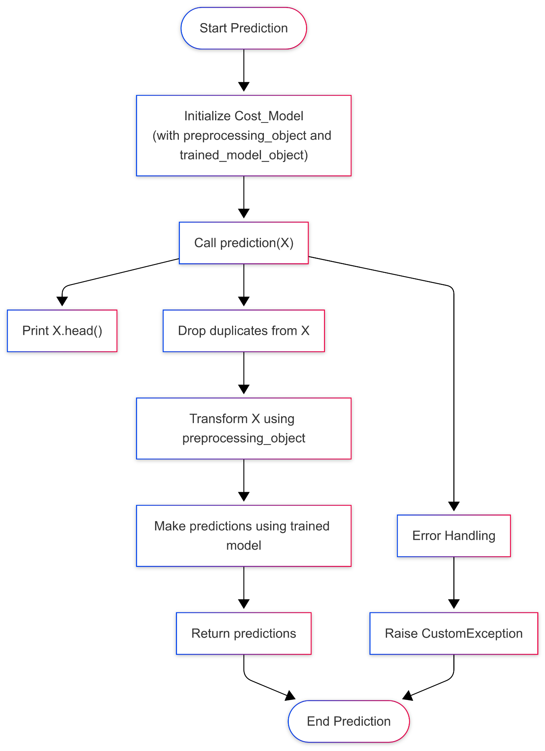

Explanation of Flowchart Components Cost_Model :
● Start Prediction: The entry point of the prediction process.
● Initialize Cost_Model: Instantiation of the Cost_Model class with the preprocessing and trained model objects.
● Call prediction(X): Invoking the prediction method with input data .
● Print X.head(): Displaying the first few rows of the input data.
● Drop duplicates from X: Removing duplicate entries from the input data.
● Transform X using preprocessing_object: Applying the preprocessing steps to the input data.
● Make predictions using the trained model: Using the trained model to generate predictions based on the transformed data.
● Return predictions: Returning the predictions made by the model.
● End Prediction: The exit point of the prediction process.
● Error Handling: Handling any exceptions that occur during the prediction process.
● Raise CustomException: Raising a custom exception if an error occurs.

Sequence Diagram Image here:
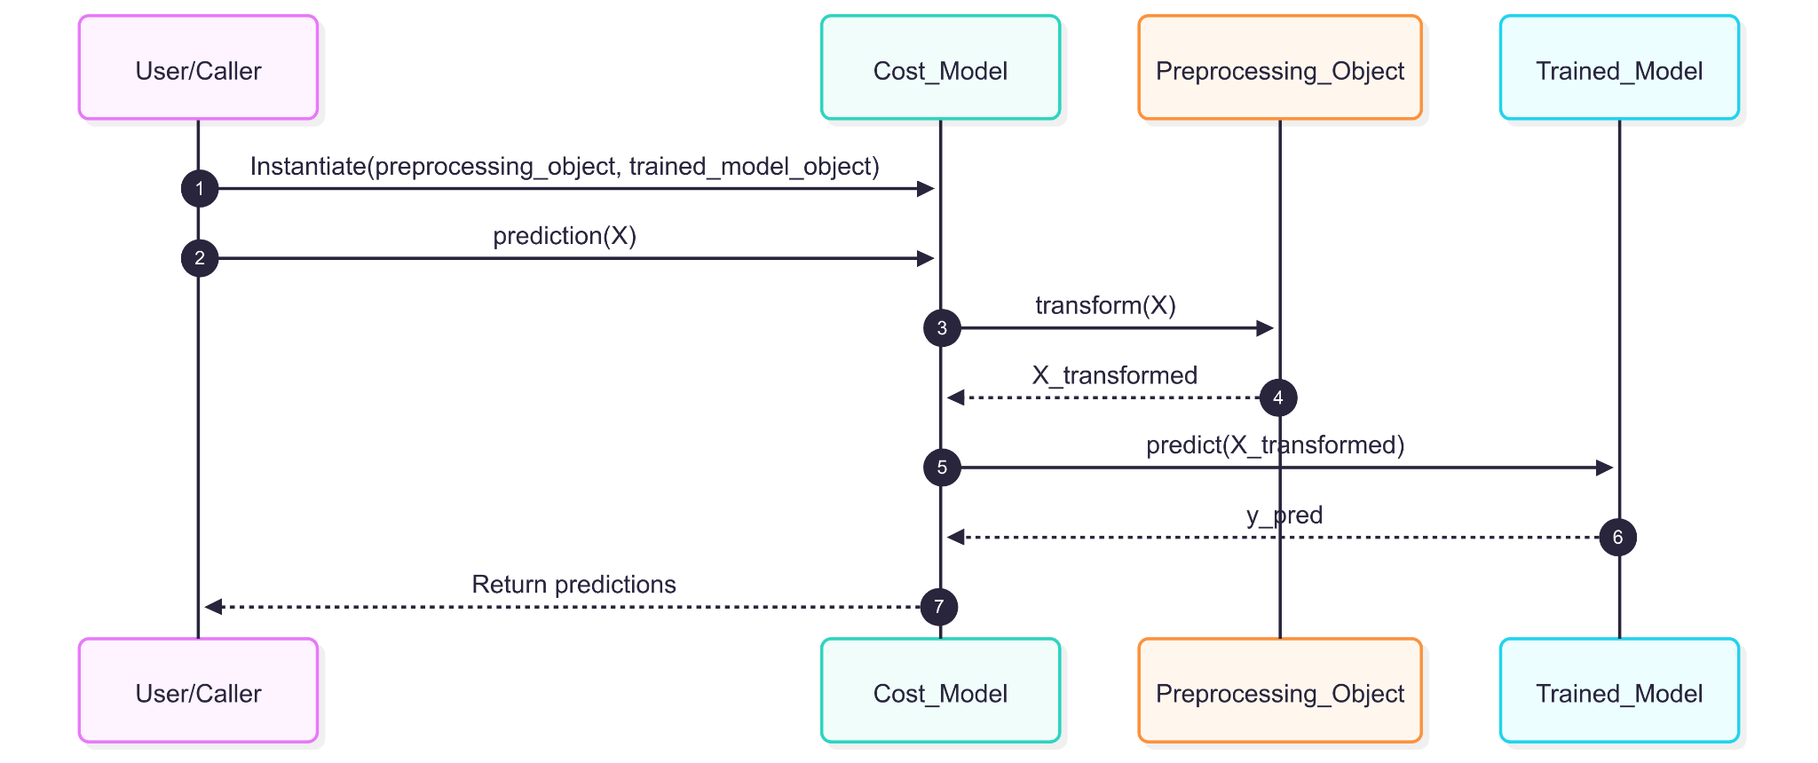

3.8 S3 to Local
Description: Pulls best model artifacts from S3 to local for inference.
Flowchart Image here:
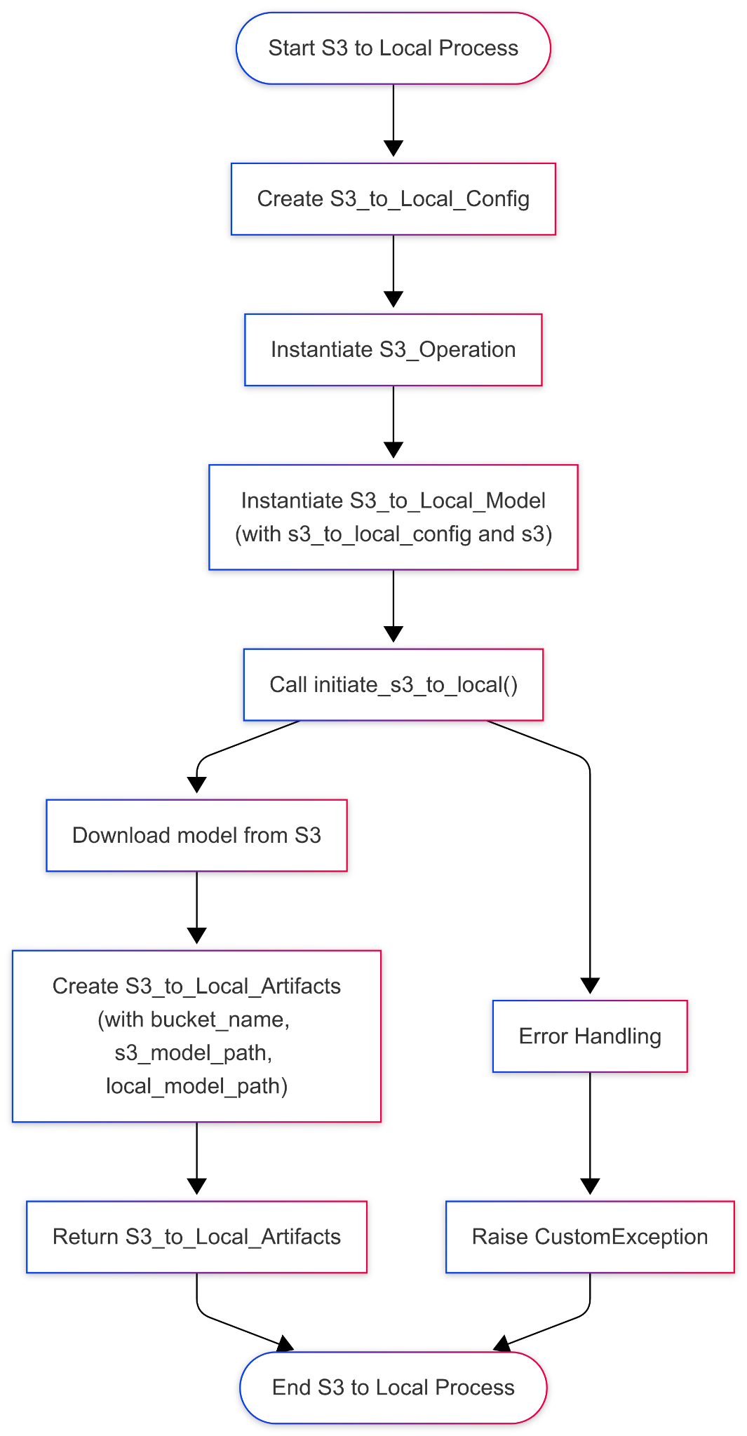

Explanation of Flowchart Components S3_to_Local:
● Start S3 to Local Process: The entry point of the S3 to local model process.
● Create S3_to_Local_Config: Creating the configuration object for S3 to local operations.
● Instantiate S3_Operation: Creating an instance of the S3_Operation class to handle S3 operations.
● Instantiate S3_to_Local_Model: Creating an instance of the S3_to_Local_Model class with the configuration and S3 operation objects.
● Call initiate_s3_to_local(): Invoking the method to download the model from S3 to the local directory.
● Download model from S3: Executing the download operation from S3.
● Create S3_to_Local_Artifacts: Creating an artifact object that contains information about the downloaded model.
● Return S3_to_Local_Artifacts: Returning the artifact containing the model details.
● End S3 to Local Process: The exit point of the S3 to local model process.
● Error Handling: Handling any exceptions that occur during the process.
● Raise CustomException: Raising a custom exception if an error occurs.
Sequence Diagram Image here:
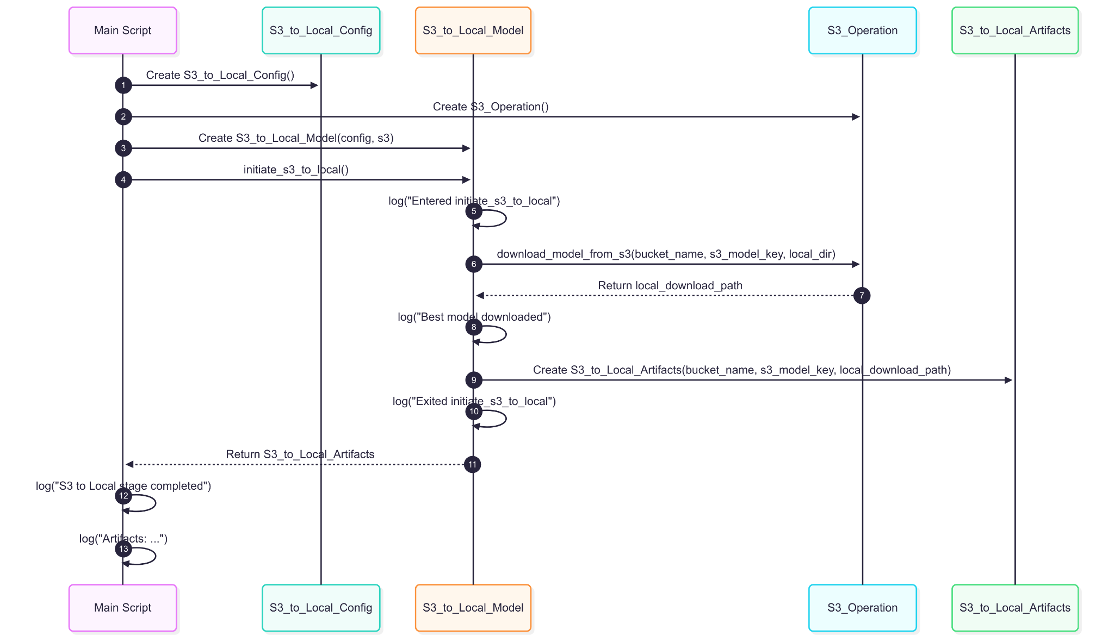

4. Pipeline-Level Architecture

4.1 Training Pipeline
Description: Orchestrates the end-to-end ML training process.
Flowchart of Training Pipeline here:
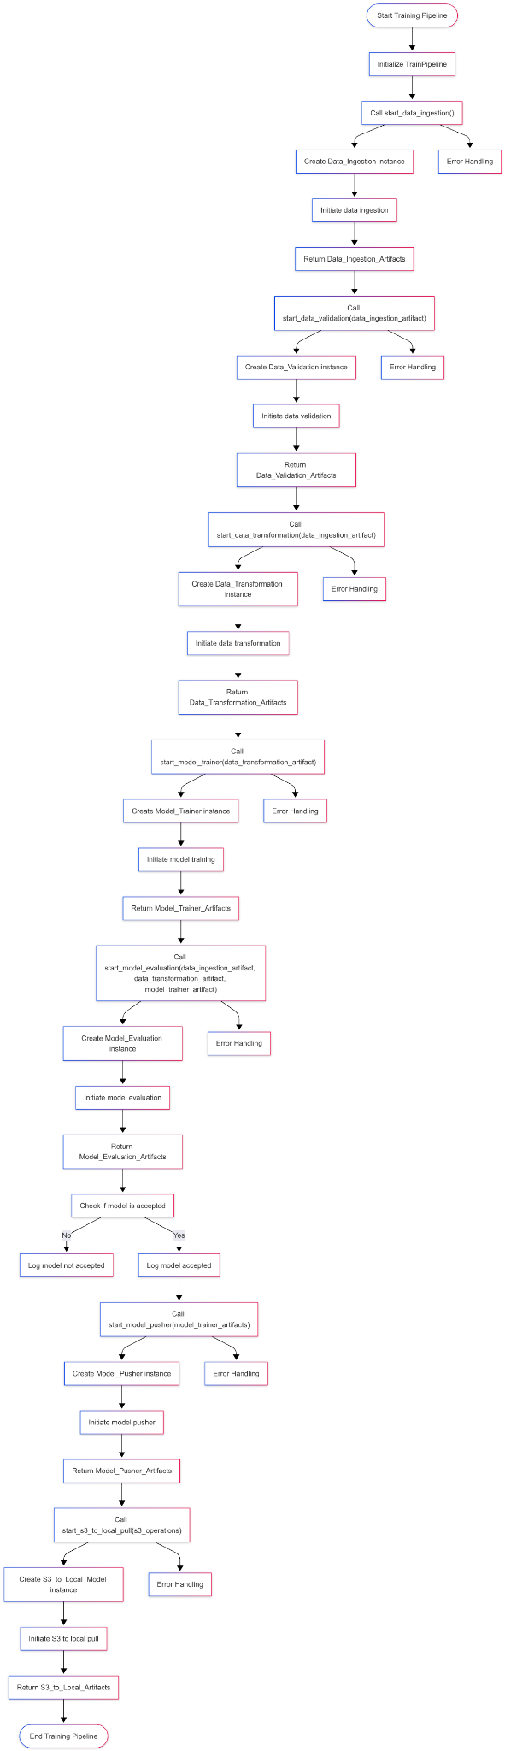

Explanation of Flowchart Training Pipeline:
● Start Training Pipeline: The entry point of the training pipeline process.
● Initialize TrainPipeline: Creating an instance of the TrainPipeline class.
● Call start_data_ingestion(): Invoking the method to start data ingestion.
● Create Data_Ingestion instance: Creating an instance of the Data_Ingestion class.
● Initiate data ingestion: Executing the data ingestion process.
● Return Data_Ingestion_Artifacts: Returning the artifacts from data ingestion.
● Call start_data_validation(data_ingestion_artifact): Invoking the method to start data validation.
● Create Data_Validation instance: Creating an instance of the Data_Validation class.
● Initiate data validation: Executing the data validation process.
● Return Data_Validation_Artifacts: Returning the artifacts from data validation.
● Call start_data_transformation(data_ingestion_artifact): Invoking the method to start data transformation.
● Create Data_Transformation instance: Creating an instance of the Data_Transformation class.
● Initiate data transformation: Executing the data transformation process.
● Return Data_Transformation_Artifacts: Returning the artifacts from data transformation.
● Call start_model_trainer(data_transformation_artifact): Invoking the method to start model training.
● Create Model_Trainer instance: Creating an instance of the Model_Trainer class.
● Initiate model training: Executing the model training process.
● Return Model_Trainer_Artifacts: Returning the artifacts from model training.
● Call start_model_evaluation(data_ingestion_artifact, data_transformation_artifact, model_trainer_artifact): Invoking the method to start model evaluation.
● Create Model_Evaluation instance: Creating an instance of the Model_Evaluation class.
● Initiate model evaluation: Executing the model evaluation process.
● Return Model_Evaluation_Artifacts: Returning the artifacts from model evaluation.
● Check if the model is accepted: Evaluating whether the model is accepted based on predefined criteria.
● Log model not accepted: Logging the outcome if the model is not accepted.
● Log model accepted: Logging the outcome if the model is accepted.
● Call start_model_pusher(model_trainer_artifacts): Invoking the method to start the model pusher.
● Create Model_Pusher instance: Creating an instance of the Model_Pusher class.
● Initiate model pusher: Executing the model pusher process.
● Return Model_Pusher_Artifacts: Returning the artifacts from the model pusher.
● Call start_s3_to_local_pull(s3_operations): Invoking the method to pull the best model from S3 to local.
● Create S3_to_Local_Model instance: Creating an instance of the S3_to_Local_Model class.
● Initiate S3 to local pull: Executing the S3 to local pull process.
● Return S3_to_Local_Artifacts: Returning the artifacts from the S3 to local pull.
● End Training Pipeline: The exit point of the training pipeline process.
● Error Handling: Handling any exceptions that occur during each method call.
Sequence Diagram here:
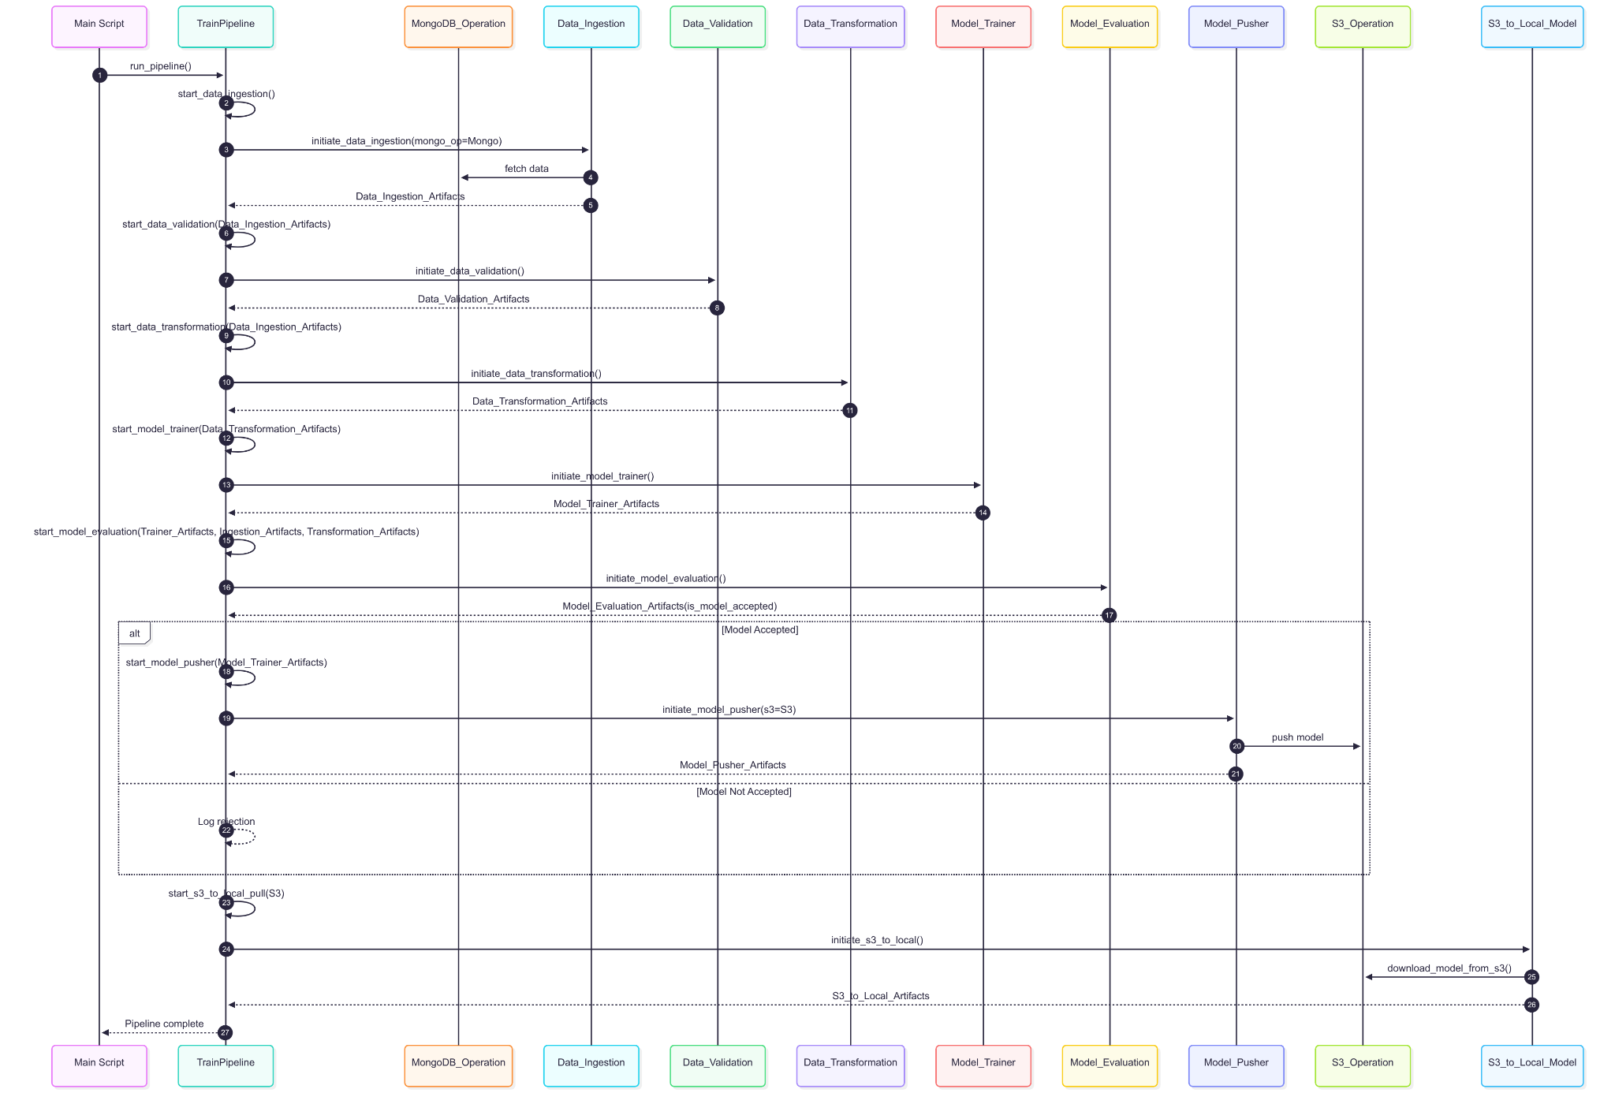

4.2 Prediction Pipeline
Description: Takes new shipment data → Prepares it → Loads best model → Predicts cost → Returns output.
Flowchart of Prediction Pipeline here:
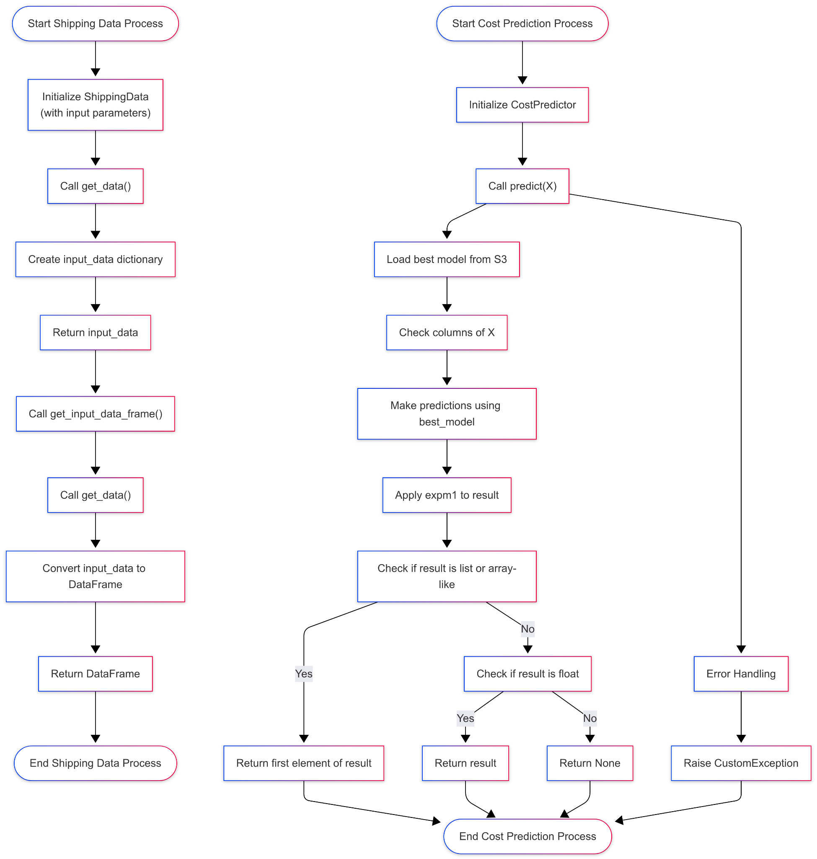

Explanation of Flowchart Prediction Pipeline :
● Start Shipping Data Process: The entry point of the shipping data process.
● Initialize ShippingData: Creating an instance of the ShippingData class with input parameters.
● Call get_data(): Invoking the method to gather input data into a dictionary.
● Create input_data dictionary: Constructing the dictionary with input data.
● Return input_data: Returning the created input data dictionary.
● Call get_input_data_frame(): Invoking the method to convert the input data dictionary into a DataFrame.
● Call get_data(): Invoking the method again to gather input data.
● Convert input_data to DataFrame: Creating a DataFrame from the input data dictionary.
● Return DataFrame: Returning the DataFrame created from the input data.
● End Shipping Data Process: The exit point of the shipping data process.
● Start Cost Prediction Process: The entry point of the cost prediction process.
● Initialize CostPredictor: Creating an instance of the CostPredictor class.
● Call predict(X): Invoking the method to predict shipment costs using the best model.
● The Load best model from S3: Loading the best model from the S3 bucket.
● Check columns of X: Verifying the columns present in the input DataFrame .
● Make predictions using best_model: Using the loaded model to make predictions.
● Apply expm1 to result: Transforming the prediction result using the exponential function.
● Check if the result is list or array-like: Checking the format of the prediction result.
● Return first element of result: Returning the first element if the result is a list or array-like.
● Check if the result is float: Checking if the result is a single float value.
● Return result: Returning the result if it is a float.
● Return None: Returning None if the result is not in the expected format.
● End Cost Prediction Process: The exit point of the cost prediction process.
● Error Handling: Handling any exceptions that occur during the prediction process.
● Raise CustomException: Raising a custom exception if an error occurs.
Sequence Diagram here:
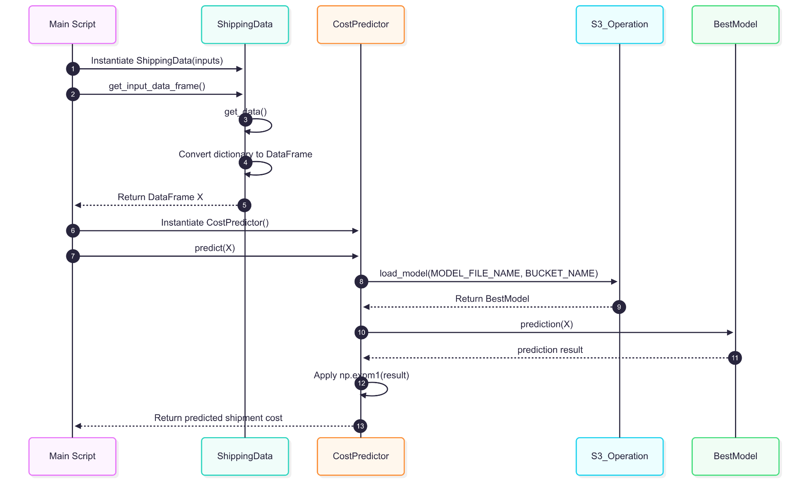

5. Application Layer (FastAPI)
The FastAPI app (app.py) provides a web-based interface for price prediction, dashboard, and KPIs.
Flowchart of Application here:
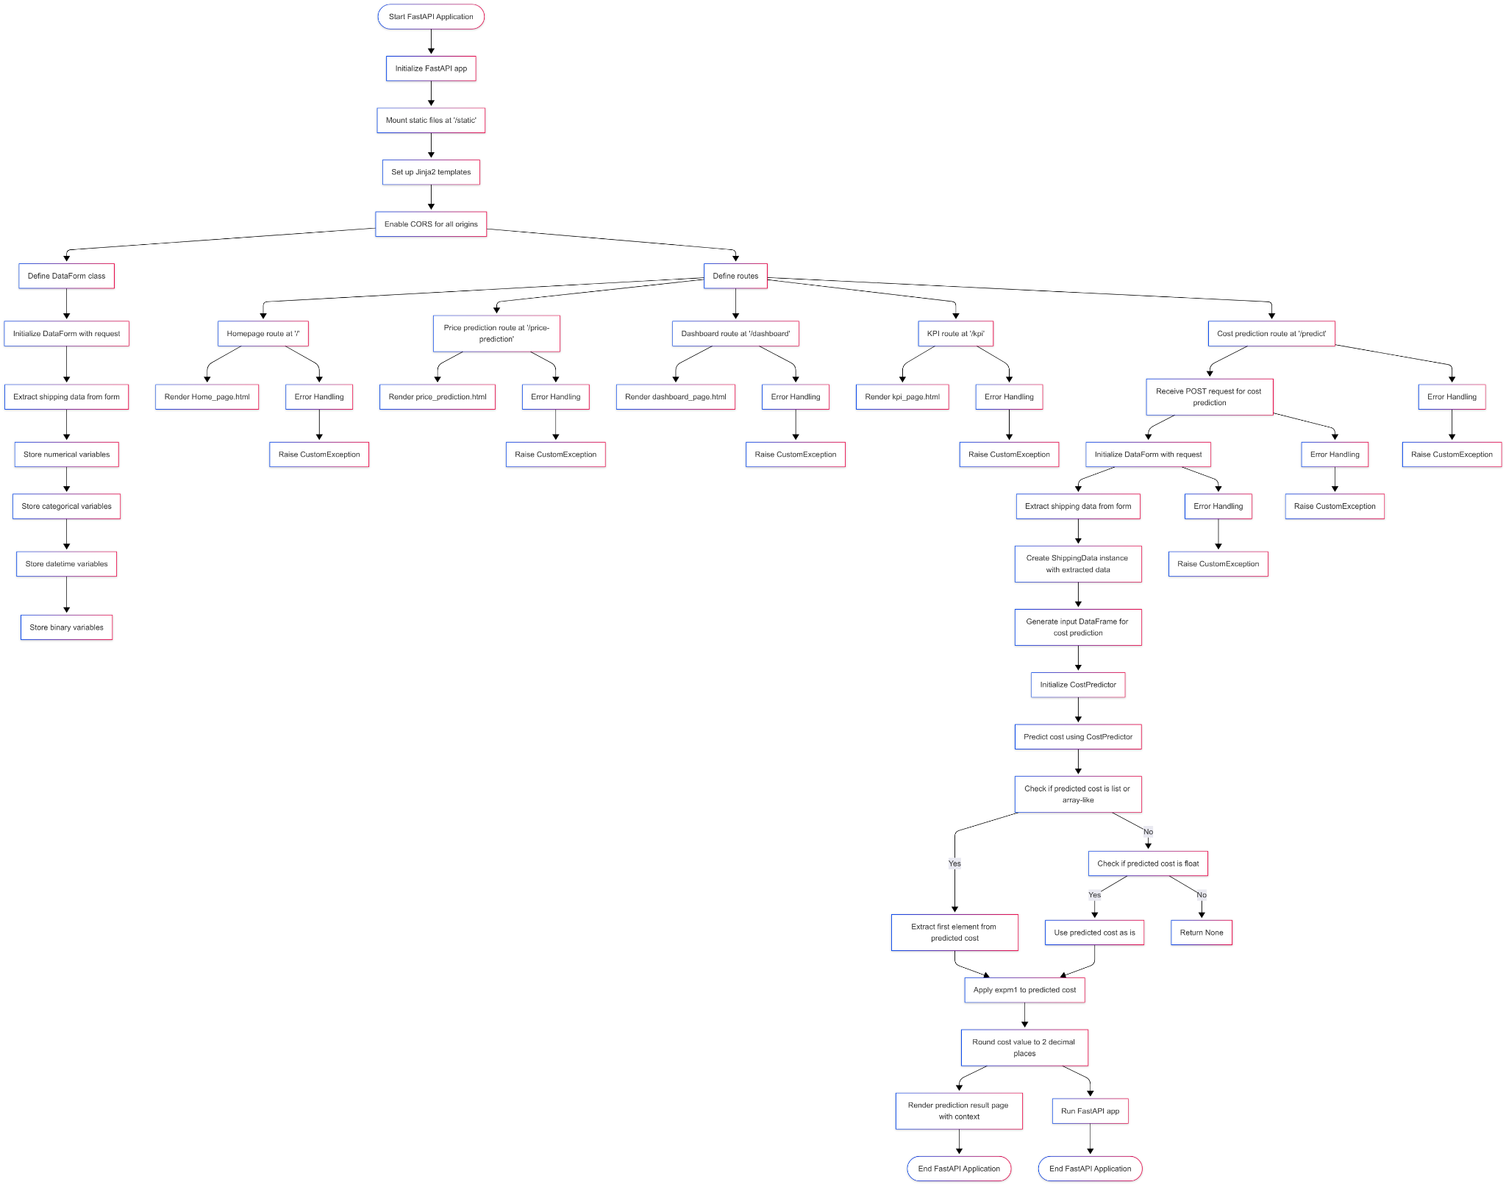

Explanation of Flowchart of Application :
● Start FastAPI Application: The entry point of the FastAPI application.
● Initialize FastAPI app: Creating an instance of the FastAPI application.
● Mount static files at '/static': Configuring the application to serve static files.
● Set up Jinja2 templates: Configure the application to use Jinja2 for HTML rendering.
● Enable CORS for all origins: Allowing cross-origin requests for testing purposes.
● Define DataForm class: Creating a class to manage user form submissions.
● Initialize DataForm with request: Creating an instance of the DataForm class with the incoming request.
● Extract shipping data from form: Extracting data from the submitted form.
● Store numerical variables: Storing numerical input values from the form.
● Store categorical variables: Storing categorical input values from the form.
● Store datetime variables: Storing date-related input values from the form.
● Store binary variables: Storing binary input values from the form.
● Define routes: Setting up the various API routes for the application.
● Homepage route at '/': Defining the route for the homepage.
● Render Home_page.html: Rendering the homepage template.
● Price prediction route at '/price-prediction': Defining the route for the price prediction form.
● Render price_prediction.html: Rendering the price prediction template.
● Dashboard route at '/dashboard': Defining the route for the dashboard.
● Render dashboard_page.html: Rendering the dashboard template.
● KPI route at '/kpi': Defining the route for the KPI page.
● Render kpi_page.html: Rendering the KPI template.
● Cost prediction route at '/predict': Defining the route for cost prediction.
● Receive POST request for cost prediction: Handling the incoming POST request for predictions.
● Initialize DataForm with request: Creating a new instance of DataForm to handle the request.
● Extract shipping data from form: Extracting the shipping data from the form submission.
● Create ShippingData instance with extracted data: Creating an instance of ShippingData with the extracted form data.
● Generate input DataFrame for cost prediction: Creating a DataFrame from the ShippingData instance for prediction.
● Initialize CostPredictor: Creating an instance of the CostPredictor class.
● Predict cost using CostPredictor: Using the CostPredictor to make a prediction based on the input DataFrame.
● Check if the predicted cost is list or array-like: Verifying the format of the predicted cost.
● Extract first element from predicted cost: Extracting the first element if the predicted cost is a list or array-like.
● Check if the predicted cost is float: Verifying if the predicted cost is a single float value.
● Use predicted cost as is: Using the predicted cost directly if it is a float.
● Return None: Handling cases where the predicted cost is not in the expected format.
● Apply expm1 to predicted cost: Transforming the predicted cost using the exponential function.
● Round cost value to 2 decimal places: Rounding the final cost value for display.
● Render prediction result page with context: Rendering the result page with the prediction and input data.
● End FastAPI Application: The exit point of the FastAPI application.
● Error Handling: Handling any exceptions that occur during various stages of the application.
● Raise CustomException: Raising a custom exception if an error occurs.
Sequence Diagram here:
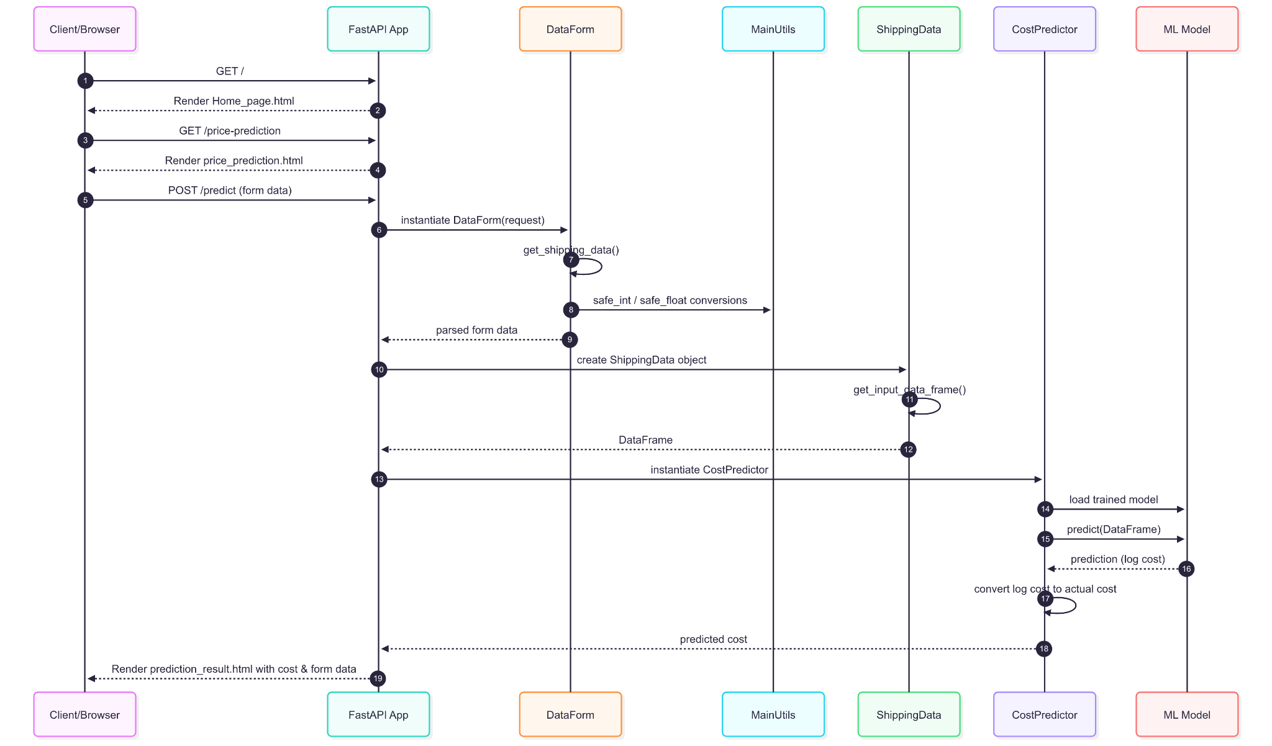

6. Deployment & Infrastructure
Our system is designed to be modular, reusable, and scalable, with clear separation between model training and model serving. The current deployment runs in AWS cloud with local training support, and can be extended for future scalability.

6.1 Storage (AWS S3)
- Whenever we run the training pipeline (via DVC), the best-performing model is selected and pushed to Amazon S3.
- S3 is the central storage hub for:
  - Trained models (here, just pushed this )
  - Versioned datasets
  - Model artifacts
- Benefits:
  - Always have a backup of production-ready models.
  - Easy retrieval of the latest model for serving in EC2 containers.
  - Ensures models are consistent across training and serving.

6.2 Training Pipeline (Local / Cloud)

Current Setup (Local Training):
- Training is triggered locally using DVC (dvc repro).
- The pipeline automatically handles:
  - Data ingestion
  - Validation
  - Transformation
  - Model training and evaluation
- The best model from the run is pushed to S3.
- MLflow logs all experiment details:
  - Model parameters
  - Training and validation metrics
  - Model artifacts

Cloud Setup (What was done):
- After local experiments, the workflow was moved to the cloud for deployment:
  - An EC2 instance was launched (Ubuntu/Linux).
  - Docker was installed on EC2.
  - The Docker image was built inside EC2, not locally.
  - The built image was pushed to Amazon ECR (Elastic Container Registry).
  - The same EC2 (or another one) pulled the image from ECR and ran the container.

Separation of Concerns:
- Training: Happens via DVC pipelines (local or could be extended to EC2/SageMaker).
- Serving: Happens via Dockerized FastAPI apps on EC2.
- The FastAPI app does not retrain models. It only loads the best model from S3 (or bundled in Docker).
- Retraining is triggered separately by running dvc repro, not by the API.

6.3 Model Serving (FastAPI)
- The deployed FastAPI application (app.py) is responsible for serving predictions.
- Functionality:
  - Loads the latest best model from S3 (or from inside the container).
  - Provides REST endpoints for clients to submit shipment details and receive predicted prices.
- Current deployment:
  - Runs on HTTP (functional but not secure).
- Future enhancement:
  - Enable HTTPS using:
    - SSL/TLS certificates (e.g., Let’s Encrypt, AWS Certificate Manager).
  - This will encrypt all communication between clients and server.

6.4 Containerization (Docker + AWS ECR + EC2)
- The entire application (code, dependencies, FastAPI server, model-loading logic) is containerized with Docker.
- Deployment Workflow:
  - On EC2, Docker is installed and the Docker image is built from the code repository.
  - The image is pushed to Amazon ECR.
  - EC2 pulls the image back from ECR (ensuring version control of container builds).
  - When the container runs, it automatically launches FastAPI and serves predictions.
  - Security groups in AWS EC2 provide controlled external access via a public HTTP endpoint.
- Benefits of Dockerization:
  - Consistent runtime across local and cloud environments.
  - Easy deployment and scaling (same image can run on multiple servers).
  - Isolated dependencies (no OS-level conflicts).
  - Reproducible deployments (ECR stores exact container versions).

6.5 Experiment Tracking (MLflow)
- MLflow is integrated into the training pipeline.
- Every training run is logged with:
  - Model parameters
  - Metrics (training/validation accuracy, loss)
  - Artifacts (saved models)
- This makes it easy to compare experiments and roll back to the best model.

6.6 Data Versioning (DVC)
- DVC (Data Version Control) manages:
  - Training datasets
  - Model outputs
  - Entire pipelines
- Benefits:
  - Reproducibility: any past run can be re-created.
  - Collaboration: code and data are versioned just like Git.
  - Automatic handling of data and model dependencies.

7. Error Handling & Logging
- Every stage of the pipeline (ingestion, validation, transformation, training, serving) includes error handling.
- If an error occurs:
  - A CustomException is raised.
  - Logs capture details of the error (timestamp, module, error message).
- Logs are stored in files for monitoring and debugging.
- The pipeline and API fail gracefully instead of crashing abruptly.

8. Security & Compliance
- S3 credentials are never hardcoded — they are managed via environment variables or IAM roles.
- Access to APIs can be restricted to authorized users.
- Current serving is on HTTP, but HTTPS will be implemented for secure, encrypted communication.
- During training and prediction, sensitive shipment/customer data is handled securely to ensure compliance with data protection standards.

9. Conclusion
The Shipment Price Prediction System is an end-to-end modular ML architecture that separates training and serving for clarity, scalability, and maintainability.
- Training:
  - Managed through DVC pipelines (currently local, can be extended to EC2/SageMaker).
  - Best models are pushed to S3 and tracked in MLflow.
- Serving:
  - Dockerized FastAPI app deployed on EC2.
  - Docker image built in EC2, pushed to ECR, and pulled for deployment.
  - Current serving is via HTTP, with a roadmap to HTTPS for secure communication.
- Governance & Reliability:
  - MLflow for experiment tracking.
  - DVC for reproducibility and versioning.
  - Central logging and error handling for easier debugging.
- Future Enhancements:
  - Auto-scaling using AWS ECS or Kubernetes.
  - Full cloud-based training pipelines.
  - Advanced IAM-based fine-grained access control.

